UNIFORM POLICY

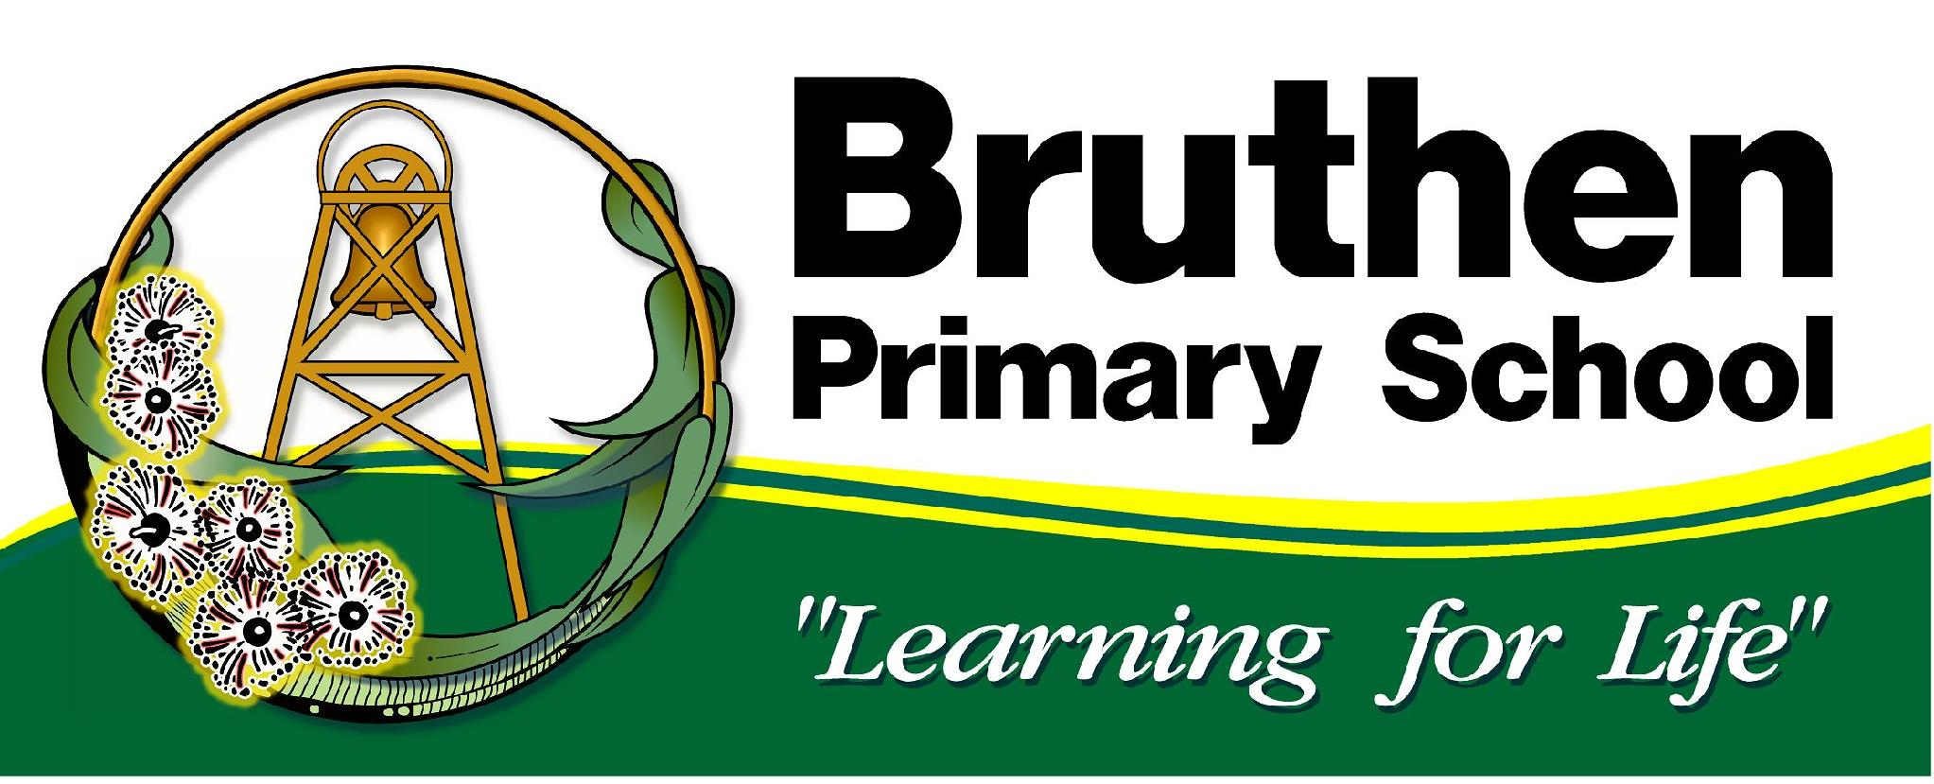

Purpose:
- to provide a sense of teamship and unity.
- to provide a non-discriminatory dress code.
- to allow the outside community to positively identify Bruthen students.
- to limit the opportunity for negative comparisons of student clothing.

Implementation:
- Students are required to wear full school uniform as outlined unless a special out-of-uniform day has been organised.
- Contact from families (note, phone call, etc) is requested if a student is unable to wear uniform on any of the uniform days.
- In the case of an excursion or special event, where parents cannot be contacted, a uniform from the spare uniform box will be provided for the day.
- Uniform items may be purchased from Nick’s in Bairnsdale or local retailers.
- Donations of second-hand uniforms will be gratefully accepted and maybe used to assist families.
- Parents who require support with clothing for their child/children are encouraged to contact the school and speak with the Principal. Uniforms may be accessed through State Schools’ Relief grants, and we can also provide second-hand uniforms free of charge.
- Shoes need to be ‘school safe’ – i.e. no thongs or scuff type shoes.
- From mid-August (exact date to be set by the school annually) to 30 April, all students must wear a sun protective hat that shades the face, neck and ears for all outdoor activities. Hats may also be worn for all outdoor activities outside of the August to April time period, by parent or student choice.
- School hats are sold at Nicks Bairnsdale.
- If a student doesn’t have a hat, they will be required to stay in the shade on the fake grass area.
- Casual hats or caps are not part of the school uniform so should only be worn on out of school uniform days.
- During winter students are permitted to wear beanies and jackets, these should ideally be green or black.

Consequences for being out of Uniform
It is expected that there will be occasions where full uniform is unavailable due to washing or drying problems etc. In these cases, we simply ask for a brief note from parents.

In the case of students repeatedly attending school out of uniform without a note or phone call, the principal will contact parents to resolve the problem.

Uniform

Tops:
- Bottle green or gold polo shirts.
- Bottle green or black track pants, gabardine pants, shorts or skorts.
- Bottle green windcheater or bomber jackets.
- Green and white check dress.
- GREEN or BLACK leggings/tights and long sleeve tops may be worn under school dresses/ polo shirts.
- Wide-brimmed bottle green hat.
- Plain crew or ankle socks

Footwear
While there is no prescribed footwear it is requested that shoes be appropriate for the types of activities done at school, that they fit comfortably and are safe. Please note that thongs and scuff type shoes should not be worn for safety reasons.

Hair & Jewellery
For health and safety reasons, we ask that hair that is shoulder-length or longer be tied back, earrings be limited to studs or sleepers, and jewellery be kept to a minimum.

Make-up
We ask that make up not be worn at school.

Evaluation:
The School Council and staff in consultation with the school community will evaluate the uniform policy bi-annually. Evaluation will take into account the reliability of the product, satisfaction with the supplier, the design of the uniform and any problems that may have occurred over the past year.

Current Supplier:
Nick’s Clothing
Ratified by School Council: August 2026
For Review: August 2028

